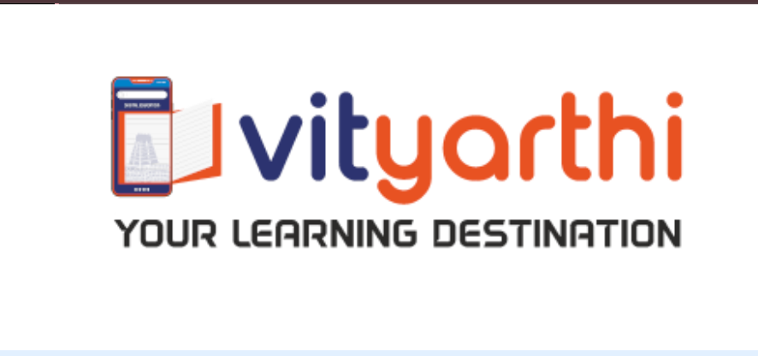
PROJECT TITLE :- Digital Literacy, Ethics, and Responsible Online Behaviour Report File

SUBMITTED BY :- AKARSH SHUKLA

REGISTRATION NUMBER :- 25BAI10715

PROGRAM :- B.TECH

COURSE CODE :- CSE0001

COURSE NAME :- CSE (AI ML)

FACULTY :- KANNAN

INSTITUTION :- VELLORE INSTITUTE OF TECHNOLOGY (Bhopal)

ACADEMIC YEAR :- 2025 – 2029

OVERVIEW OF THE PROJECT:-

This project was completed as part of the role of a Student Digital Ambassador at the college. The main objective of the assignment was to create a Digital Literacy Portfolio that helps students understand how to use digital tools responsibly and professionally. In today’s digital world, students must know how to build an online presence, communicate professionally, and stay safe while using the internet.
The project includes several tasks organized into different folders such as task-1-presentation, task-2-portfolio, task-3-platforms, task-4-email-etiquette, and task-5-cybercrime. These tasks involve creating an infographic on digital literacy, setting up professional profiles on platforms like GitHub, LinkedIn, and Stack Overflow, designing a Google Form quiz, writing professional emails, and preparing checklists related to social media use and cyber safety. The scenario assumes that the student ambassador will later present this portfolio to the faculty committee and share the knowledge with classmates to promote responsible digital practices.

TASK 1 :- Create a Digital Literacy Awareness Infographic
Create a single infographic or visual slide that covers at least 3 of the following topics: what digital literacy is, useful digital tools for students, safe internet practices, professional online presence, email etiquette.
REPORT:-
For creating the infographic, I used Canva, an easy online design tool that helps in making presentations, posters, and infographics with ready-made templates. Canva allowed me to organize the information clearly using icons, colors, and simple text so that the content is easy to understand for students.
The design of my infographic covers three important topics related to digital literacy. First, it explains what digital literacy is, which means the ability to use digital devices, the internet, and online platforms effectively and responsibly. Second, the infographic highlights useful digital tools for students, such as Google Docs, Google Drive, and online learning platforms that help students collaborate, store files, and complete assignments efficiently. Third, it presents safe internet practices, including using strong passwords, avoiding suspicious links, and protecting personal information online. These points are shown using icons and short bullet points so that viewers can quickly understand the key ideas.
While creating the infographic, one interesting part was selecting visuals and arranging them in a clear layout so the information looks attractive and easy to read. The main difficulty I faced was deciding how to summarize important information in a limited space without making the slide look crowded.

TASK – 2:- Build Your Student Digital Portfolio

A professional digital presence is no longer optional — it is expected. In this task, you will set up your foundational portfolio across the key platforms that employers, internship coordinators, and the academic community check
REPORT:-
For this task, I created or updated my profiles on GitHub, LinkedIn, and Stack Overflow. These platforms are widely used by students and professionals in the technology field to share knowledge, build portfolios, and connect with others.
GitHub is mainly used for storing and managing code using version control. I created a profile README repository with my name, branch, year, and a short sentence about my learning goals. This helps others understand my interests and the projects I am working on. LinkedIn is a professional networking platform where people showcase their education, skills, and achievements. I updated my LinkedIn profile by filling in the Education section with my current degree, institution, and expected graduation year. Stack Overflow is a popular question-and-answer platform for programmers where users can ask coding-related questions, share solutions, and learn from the experiences of other developers.
Over the next four years, I plan to use GitHub to upload and maintain my academic projects and coding assignments. I will use LinkedIn to build a professional network, connect with industry professionals, and explore internship opportunities. I also plan to use Stack Overflow to ask questions when I face programming problems and to learn new concepts by reading discussions and solutions shared by experienced developers.

TASK 3:- Explore Coding & Collaboration Platforms
PART B:-
Create a Google Form with exactly 5 questions that could be used as a 'Digital Literacy Awareness Quiz' for your batchmates. Include at least one multiple choice question and one short answer question.
REPORT:-
For this task, I used Google Forms, which is an online tool provided by Google to create surveys, quizzes, and questionnaires easily. It allows users to design forms with different types of questions and automatically collect responses. Using this platform, I created a Digital Literacy Awareness Quiz for my batchmates with exactly five questions. The quiz included different question types such as multiple choice questions and a short answer question. The questions were designed to test basic awareness about digital literacy, safe internet practices, strong passwords, cyberbullying, and responsible use of the internet.
Through this activity, I practised creating online forms, selecting appropriate question types, and organizing questions in a clear format. I also learned how to set correct answers and structure the quiz so that it is easy for participants to understand.
These tools will help me academically in many ways. Google Forms can be used to conduct surveys, quizzes, and feedback forms for academic projects or research work. It also helps in collecting and analyzing data quickly. Learning to use digital tools like Google Forms improves my digital literacy skills and helps me work more efficiently on assignments, group projects, and presentations during my academic studies.

TASK 4:- Draft a Professional Email & Etiquette Guide
PART B:-
Create a simple checklist (can be a table or a bulleted list in your report) with at least 5 Do's and 5 Don'ts for responsible social media use as a college student.
REPORT:-
While studying responsible social media use, I learned how important digital communication is for college students. One situation where poor digital communication can cause a serious problem is when a student posts an inappropriate or offensive comment about a teacher or college on social media. Even if the student intended it as a joke, the post could be seen by others, shared widely, and damage the student’s reputation or even lead to disciplinary action from the college.
In such a situation, the problem could have been avoided by thinking carefully before posting anything online. Students should always check whether their message is respectful, appropriate, and does not harm others. Following responsible social media practices such as respecting privacy, avoiding negative comments, and maintaining a professional online image can prevent misunderstandings and conflicts.
This example shows that digital communication should always be handled responsibly because content shared online can spread quickly and have long-term effects on a person’s academic and professional life.

TASK 5:- Cybercrime Awareness Case Study & Prevention Guide
PART B:-
Create a 'Stay Safe Online' checklist with at least 8 specific, actionable prevention tips relevant to college students in India
REPORT :-
While researching the topic “Stay Safe Online”, I learned many important ways students can protect themselves while using the internet. What surprised me the most was how easily personal information can be misused if people are not careful online. Many cyber crimes happen simply because users click on suspicious links, share personal details, or use weak passwords. I also discovered that students in India are often targeted through phishing emails, fake job offers, or fraudulent messages on social media.
Through this research, I understood the importance of following simple prevention tips such as using strong passwords, enabling two-factor authentication, avoiding public Wi-Fi for important work, and verifying unknown links before clicking them. These small actions can significantly reduce the risk of cyber threats.
One habit I will personally change after learning about this topic is improving my password security. I will start using stronger and more unique passwords for different accounts and avoid reusing the same password across multiple platforms. This will help protect my personal and academic information from being accessed by unauthorized users.

CONCLUSION
Through this project, I learned the importance of digital literacy and responsible online behavior. I gained practical experience in creating professional online profiles, using tools like Google Forms and Canva, and understanding how platforms such as GitHub, LinkedIn, and Stack Overflow can help in academic and career development.
I also learned how to write professional emails, maintain proper online etiquette, and identify cybercrime risks along with ways to prevent them. The project helped me understand how important it is to build a positive digital presence and protect personal information online. Overall, this assignment improved my technical awareness, communication skills, and ability to use digital platforms effectively for academic and professional growth.

REFERENCES
The following tools and platforms were used during the project:
- Canva / Prezi – for creating the infographic or visual presentation
- Google Forms – for designing the Digital Literacy Awareness Quiz
- GitHub – for creating a portfolio and profile README
- LinkedIn – for building a professional networking profile
- Stack Overflow – for engaging with programming discussions and learning solutions
- Internet resources and online articles – for researching digital literacy, email etiquette, and cyber safety practices

